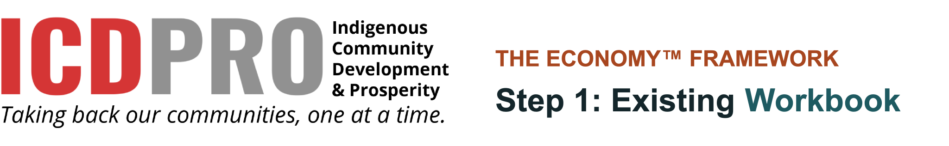
The best place to start is right where you’re at.
Community
Planning group lead
Date started
Date completed

This workbook belongs to your community.
ICDPRO does not collect or store your answers, maps or plans. Decide together where this workbook will be kept and who can see it, especially information about land and people. This approach is guided by the First Nations principles of OCAP®: ownership, control, access and possession.
OCAP® is a registered trademark of the First Nations Information Governance Centre (FNIGC).

How to use this workbook
This workbook accompanies Step 1: Existing on the ECONOMY™ Framework website. Use them together: the web page explains each activity, and this workbook is where your community records its findings.

What’s inside
 | Worksheet | Use it for
1A | Starting questions | Before you begin: who is involved, how much time and support you have.
1B | Community asset inventory | Record what and who your community already has.
1C | Existing businesses | List every business in your community, big or small.
1D | Groups and organizations inventory | Activity A: list every group, organization and institution.
1E | Gifts and talents conversation guide | Activity B: learn the gifts and skills of community members.
1F | Community asset map | Activity C: lay out your assets on a place map or circle map.
1G | Territory audit register | Activity D: record who is operating in your territory.
 | Our Step 1 decisions | Decide together what you learned and what comes next.

Tips
- Fill it in together. A planning group that reflects your whole community will identify more assets than one person.
- Print it or type directly into the editable Word version. Add rows or pages whenever you need them.
- Worksheets 1D and 1E can run simultaneously with different teams.
- Review your assets regularly. New ones are always coming onto the scene.
- This workbook serves as the first chapter of your community’s plan and the starting point for Step 2.

Would it be helpful to work with someone?
ICDPRO’s team can facilitate your asset mapping and territory audit with your community. angela@ICDPRO.ca · 780-717-8296
Worksheets 1D to 1F adapt ideas from the Community Tool Box, University of Kansas (ctb.ku.edu).
WORKSHEET 1A

Starting questions
Answer these as a group before you begin. Your answers will shape how extensive your search will be and which methods you choose.
“The best resources you have right now are what and who you have right now.”
— Angela Adsit, Indigenous Community Development & Prosperity

Our planning group
A planning group that reflects your whole community: leadership, staff, Elders, members, and youth. Students or interns can be a great help.
Name | Role in the community | How they will help

WORKSHEET 1A

Five starting questions
Answer these together. Your answers shape the scope of your search.
- How large is the community we’re working with?
Larger communities need more people and different methods.

- Who is available to do the work?
One person, a small group, or a whole department? Who else can we recruit early?

- How much time do we have?
The more time we allow, the more assets we will uncover.

- What resources can we count on?
Printing, supplies, a map of our territory, paid time for helpers.

- What will we do with the results?
A community directory, a plan, a presentation to leadership?

WORKSHEET 1B

Community asset inventory
A community asset is anything that can be used to improve the quality of community life. Record what and who your community already has. Groups and organizations go on Worksheet 1D, businesses on 1C, and individual gifts and talents on 1E.
“Who makes businesses? Who does the work? People. You have people.”
— Angela Adsit, Indigenous Community Development & Prosperity

People
Registered members
Members living on reserve
Members living off reserve
Youth (under 25)
Elders (65 and over)
Fluent language speakers
Elders and knowledge keepers
Tradespeople and certified professionals
Post-secondary graduates
Off-reserve members with skills, businesses or networks to share

Other/Notes:
WORKSHEET 1B

Places: land and natural resources
Reserve land (hectares)
Traditional territory (hectares)
Land available for development
Forests, minerals and water
Fish, wildlife and farmland
Solar, wind or hydro potential
Trails, fishing, camping and gathering places
Location: nearby highways, ports, markets, major projects or visitors
Other/Notes:

Culture and stories
Language: speakers, programs and resources
Ceremonies, gatherings and celebrations
Traditional skills, arts and crafts
Traditional economy: harvesting, trapping and food sharing
Stories of times the community came together for change
Other/Notes:
WORKSHEET 1B

Places: buildings and infrastructure
Asset | How many | Good / needs repair / unused | Notes
Band office and administration buildings
Community centre and meeting spaces
School and education facilities
Health centre
Housing units
Unused buildings
Recreation: rink, playground, sports fields
Roads, airstrip or marine access
Water, sewer, power and internet
Commercial or industrial space
Other/Notes:

Financial assets
Some of this information is confidential. Record only what your community agrees to record here.
Own-source revenue
Trust or settlement funds
Investments and reserves
Access to capital, credit and lending
Grants and funding the community already receives
Other/Notes:
WORKSHEET 1B

Rights and agreements
Treaty and title rights
Impact benefit agreements
Existing contracts and partnership agreements
Land code and community laws
Policies (for example: economic development, consultation, finance)
Other/Notes:

Relationships
Tribal council and other Nations
Federal, provincial and municipal governments
Industry partners
Universities, colleges and researchers
Non-profit and funding organizations
Other/Notes:

Plans and records
Past community or strategic plans
Studies and reports
Maps and land-use information
Archives, photos and recorded stories

Other/Notes:
WORKSHEET 1C

Existing businesses
Band-owned, member-owned, and home-based businesses provide jobs and keep money circulating in the community. List every one, big or small. Outside businesses operating in your territory go on Worksheet 1G.
“Focusing on entrepreneurship, other businesses in your community and big projects in your territory will be the most effective way to build economic development in your community.”
— Angela Adsit, Indigenous Community Development & Prosperity
Owned by: Band or EDC · Member · Home-based · Partnership or joint venture
Business | Owned by | What it does | Jobs (total / members) | Year-round or seasonal | Contact person | What would help it grow
Other/Notes:

How can we support our existing businesses right now?

WORKSHEET 1D

Groups and organizations inventory
Start with what you know. Write down every group, organization, and institution that comes to mind, then add to the list from other sources. Friends and colleagues may know of groups that aren’t on anyone’s list. Add more pages as needed, and sort the list by type or location when you’re done.
Where we looked: ☐ Band office ☐ EDC business list ☐ Bulletin boards ☐ Websites ☐ Social media ☐ Asked friends and colleagues
Type: People · Places · Services and groups · Businesses · Culture and stories
Group, organization or institution | Type | What it offers the community | Contact person | Where it is

WORKSHEET 1E

Gifts and talents conversation guide
Every person in your community has gifts. Asking people about their gifts often encourages them to share them with others.
“…we need to move beyond just ‘making money’. We need to learn how to be prosperous, too.”
— Angela Adsit, Indigenous Community Development & Prosperity

Part 1: Plan your conversations
Who will we ask?
☐ Every household
☐ A set number of people: ______
☐ As many people as we can reach
What are we asking about?
☐ Skills and gifts people have
☐ Things people would like to learn
☐ Both
How will we ask? Personal approaches work best.
☐ Kitchen-table visits
☐ Community gatherings
☐ Phone calls
☐ A short survey
Who will hold the conversations
Try your questions on a few people first. Adjust anything that is unclear, then begin. Notes from our test conversations:

WORKSHEET 1E

Part 2: Conversation sheet
Make a copy of each conversation. Ask permission before writing anything down, and explain how their answers will be stored. People may choose not to provide their name.
Name (optional)
Date
Conversation held by

What are you good at? What do people come to you for?

What knowledge or skills do you have? (For example: language, harvesting, a trade, art, cooking, caring for others, business, technology, or sport)

What would you be willing to share or teach others?

What would you like to learn?

May we contact you when there is an opportunity to use or share your gifts? ☐ Yes ☐ No
If yes, best way to reach you:

WORKSHEET 1E

Part 3: What we heard
Bring your conversation sheets together and count the gifts and skills you identified.
Gift, skill or knowledge | Number of people | Willing to share or teach | Want to learn it

Biggest surprises:

WORKSHEET 1F

Community asset map
Seeing your assets laid out often reveals patterns you might otherwise overlook. Choose one approach or both.
“Little businesses are just as important as big businesses.”
— Angela Adsit, Indigenous Community Development & Prosperity

Option 1: Place map
- Print a large map of your community and territory.
- Choose a colour of dot for each type of asset and fill in the key below.
- Mark each asset from Worksheets 1B to 1E where it is.
- Step back and look. Areas with few assets may be good targets for development later.
Dot colour | Type of asset | How many | Notes
 | People
 | Places
 | Services and groups
 | Businesses
 | Culture and stories

Notes from our place map:

WORKSHEET 1F

Option 2: Circle map
Draw rings outward from places, to institutions, to organizations, to services, to informal groups, to individuals. Write each asset in its ring, then draw lines to show how they connect.
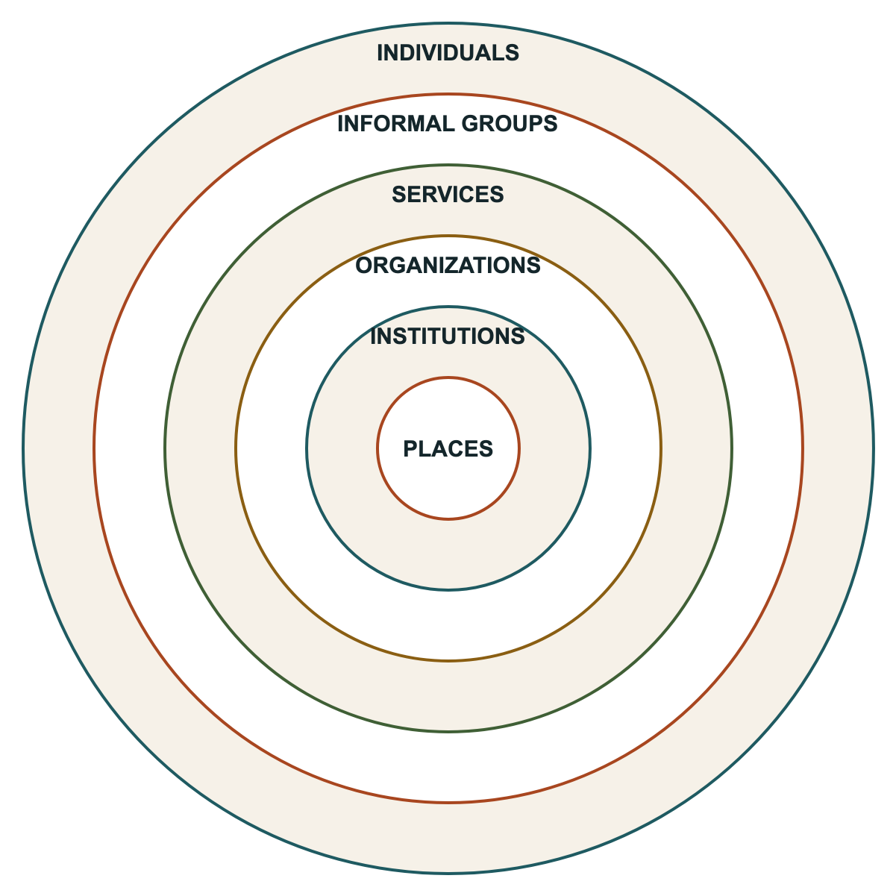
Write your assets in the rings or draw your own larger version on the wall.
WORKSHEET 1F

What our map shows us
Where are assets clustered? Where are there few assets?

Which groups or people are connected? Which could work together but haven’t yet?

Which areas with few assets might be good targets for future development?

WORKSHEET 1G

Territory audit register
Your recognized territory is the area where incoming businesses are expected to consult with you before starting work. Post a large map of your territory somewhere visible, then record every business operating there. If a business did not consult you, decide whether to contact them to begin a relationship.
“…it is your right as the rightful owner of that Indigenous land, and it is your responsibility to protect the land for future generations.”
— Angela Adsit, Indigenous Community Development & Prosperity
Priority to approach: 1 = we already have a relationship (recommended first) · 2 = closest to our community · 3 = in our territory the longest · 4 = could benefit members through jobs or training
Business | What they are doing | Where in our territory | How long here | Consulted us? (Yes / No / Unsure) | Relationship already? | Priority (1–4) | Next step and who

WORKSHEET 1G

Be ready before you reach out
The more prepared you are, the stronger your position, and the more businesses will want to work with you.
Do we know what we want? | What does our community need? | Do we have a process for engagement and consultation?

STEP 1

Our Step 1 decisions
Answer these together before you move on to Step 2.
“The more prepared you are, the better. The more confident you are in your approach, the less pushback you will receive.”
— Angela Adsit, Indigenous Community Development & Prosperity
- Which assets surprised us? Which did we not know we owned?

- Which assets are underused and could be put to work immediately?

- Which groups or people could work together but haven’t yet?

- Which businesses in our territory should we approach first, and why?

- Who will keep our asset list up to date, and how often will we review it?

Completed by |  | Date
Next review |  | Kept by

Next: Step 2 · Coming

